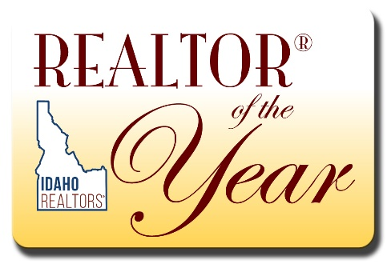

2020 REALTOR® of the Year Application
Due August 5th, 2020
Application MUST be submitted by due date, include a candidate statement and current high-resolution photo.

Nominee Information
Please enter the information below about the nominee
Name of Nominee
Firm Name
Address
Phone Number
Date when this information can be released

Sponsor Information
Sponsor's Name
Firm/Association/Board Sponsor
Address
Email
Phone Number

QUALIFICATIONS FOR REALTOR® OF THE YEAR

Limited to the Last 5 Years
REALTOR® SPIRIT
10%
General description of candidate’s faithfulness to principles of organized real estate, laws and regulations of his/her Board/Association and the REALTOR® Code of Ethics, time and effort expended in furthering principles of good real estate practice among other real estate brokers, press, public. List in chronological order (beginning with the most recent) any REALTOR® awards or special recognitions (including RPSF/RPAC) participation.
REALTOR® Spirit:

CIVIC ACTIVITIES
20%
Participation and offices held in local, state, and national civic and service clubs, membership in charitable organizations and activities there. Political appointments or elections to public offices or commissions. Involvement of candidate in community projects that enhance economic development, pride, and awareness of area.
Organization:
Position(s) Held:
Dates held:
Civic Activities:

BUSINESS AND EDUCATIONAL ACCOMPLISHMENTS
10%
Business history of the candidate since entering the real estate business, including educational courses attended and designations earned. Describe the candidates standing in the community as a REALTOR® and list specific contributions to the community along real estate lines. You may include business reputation with other REALTORS®, imaginative and creative marketing concepts, and clientele testimonials.
Business and Educational Accomplishments:

LOCAL BOARD ACTIVITIES
15%
List committee/task force and elected office assignments in chronological order beginning with the most recent. In addition, describe special assignments, task force participation, special events, committee assignments, appointed positions, and special achievements or recognition.
Local Board Activities:

STATE ASSOCIATION ACTIVITIES
30%
List Committees, Task Forces, and elected office assignments in chronological order beginning with the most recent. Describe special assignments, task force participation, special events, committee assignments, appointed positions, and special achievements or recognition. Attendance and participation at state meetings and conventions.
State Association Activities:

NATIONAL ASSOCIATION ACTIVITIES
15%
National offices and committee work, membership and work in Institutes, Societies, and Councils including National Honor Society, also attendance at national conventions, meetings, etc.
National Association Activities:

*Please ask your candidate to submit a one-paragraph statement to the IR ROTY Task Force that indicates why membership in the REALTOR® organizations is of value to your candidate.

Please submit both the one-paragraph statement as well as a high-resolution photo with your application.

*If candidate paragraph is unavailable due to confidential nomination please submit a document indicating why candidate paragraph is not being included and when it will be available. For questions contact Faith Malloy at email: fmalloy@idahorealtors.com

