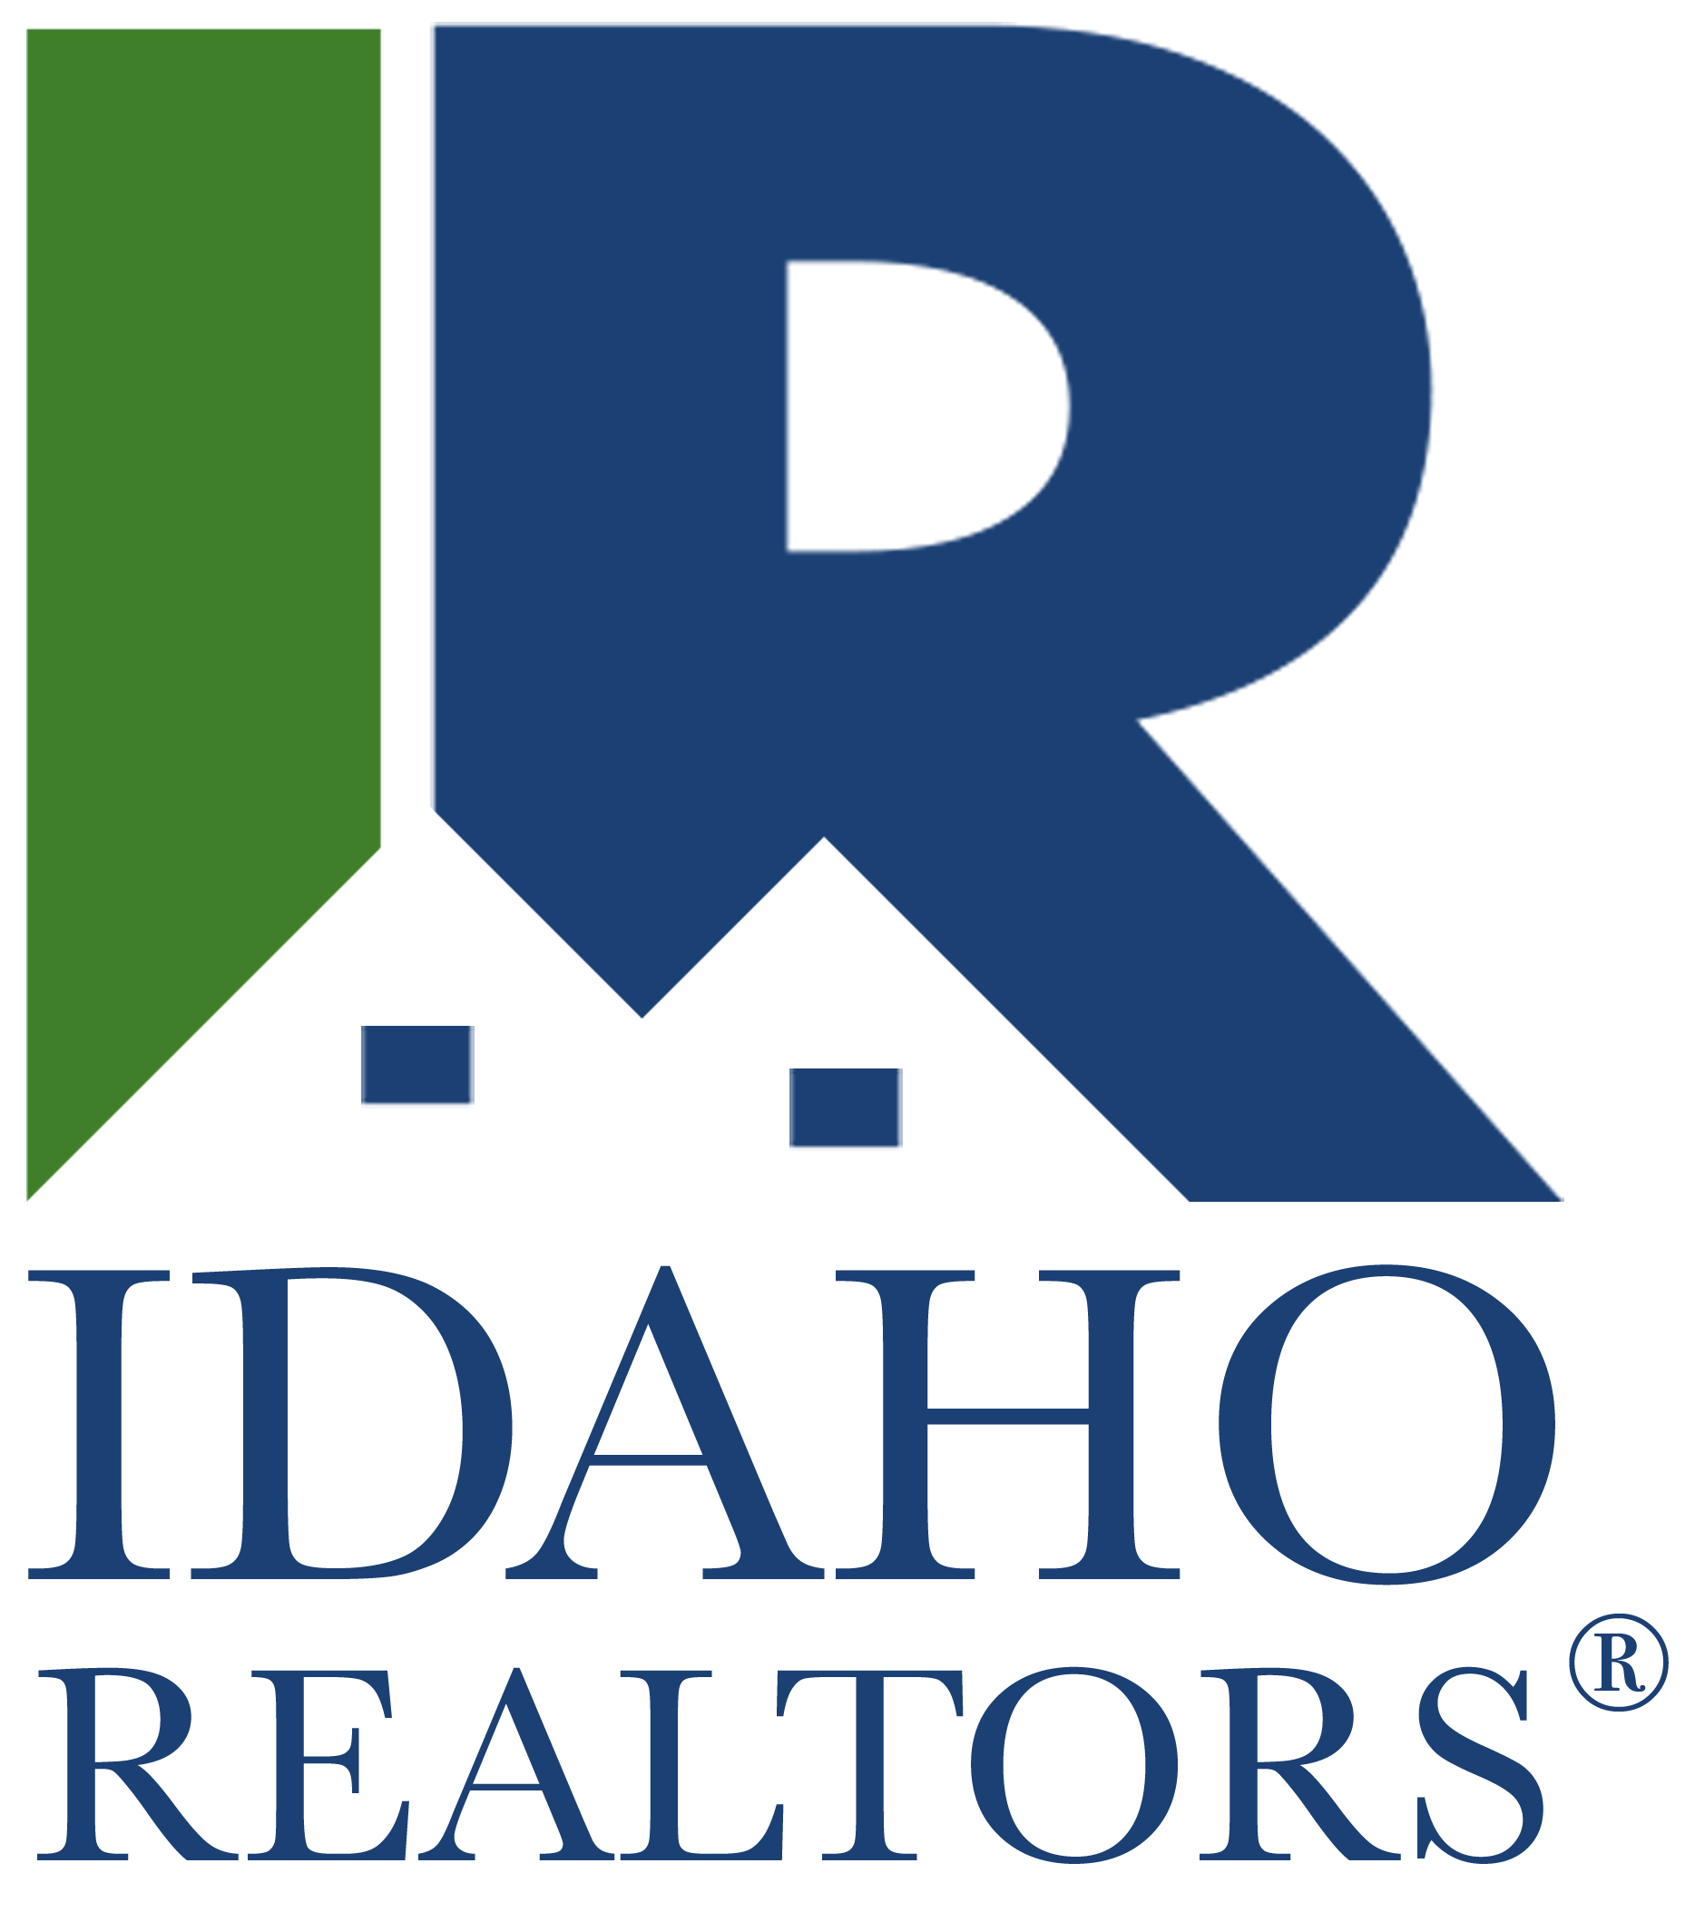
Idaho Association of REALTORS®
2018 Honor Society Application
Fax or email completed form to the IR (attn. Lisa Farnam)
at 208.922.6846 or lfarnam@idahorealtors.com by August 15th.

Applications received after August 15th
will not be recognized at the IR Conference.

Qualification period is from August 2017 to July 2018.

REALTOR® Honor Society
The REALTOR® Honor Society was first formed in Wisconsin in 1977 to enhance and recognize the professional standards of the WRA membership through voluntary educational offerings, participation at the Local, State and National levels and through service to the community.
The primary purpose of the REALTOR® Honor Society is to encourage Board/Association participation among members in order that they might be better educated and active members who serve their clients and in return bring credit to themselves and the real estate industry.
The program was designed for REALTORS® new in the business as well as those who have been members for years. It is intended to reward those members who actively participate in REALTOR® functions.
Points are awarded to members for educational participation and achievement with an annual goal of achieving an award granting membership in the REALTOR® Honor Society.
To maintain membership in REALTOR® Honor Society, members must re-qualify each year by obtaining 100 points. The qualification period is from August 1 to July 31 of each year.
All Idaho members will be recognized at the Awards Luncheon at Convention in Boise in October and will be awarded either an Honor Society Pin, Certificate, Year Bar (gratuitous), or a Plaque (at REALTORS® own expense).
Please fill out the attached application, have it signed, and submitted to the IR office by August 15th, 2018. If you have any questions about Honor Society, please contact Lisa Farnam at Idaho Realtors at 208-922-6846 EXT: 104 or lfarnam@idahorealtors.com.

NAME (PLEASE PRINT) ______________________________________________________________________________________

ASSOCIATION/BOARD_______________________________________________________________________________________

Local Meeting Attendance
Attendance of over 60% of scheduled local board meetings
will be one point per 1% over 60% to a maximum of 40 points.
Total Points: _________

Local Board Activity
Committee Member – 5 pts
Committee Chairperson – 10 pts
Officer and Directors – 20 pts
President – 35 pts
Total Points: _________

State Association Activity
Task Force/Committee Member – 5 pts
Task Force/Committee Chairperson – 10 pts
State Director – 20 pts
Executive Committee – 50 pts
Participant in 2017 Leadership Academy – 25 pts
Total Points: _________

National Association Activity
Committee Member – 10 pts
Committee and Chairperson – 40 pts
Officers and Directors – 50 pts
Total Points: _________

Conference Attendance
Attended 2017 IR Business Conference – 10 pts
Attended 2017 NAR Convention(s) – 20 pts per convention
Total Points: _________

Membership Recruitment
5 points per member recruited
Total Points: _________

Local Board REALTOR® of the Year
35 pts (only in the year selected)
Total Points: _________

REALTOR® Institute
Must have been completed between August 1, 2017 and July 31st, 2018
Received GRI Designation during qualification period – 40 pts
Working on GRI Designation – 10 pts per attended class
Total Points: _________

Other Education (max. total 20 pts)
Real Estate related course – 2 pts per hour
Designation courses – 2 pts per hour
Total Points: _________

Grand Total: ____________
(Must be 100 points to qualify)

APPROVED BY:
(Must be Local Board/Assoc. President or Executive Officer)

Print Name: __________________________________________________________________________________

Signature: ______________________________________________________________ DATE: _______________

PLEASE CHOOSE ONE:

_____ PIN _____ CERTIFICATE _____ YEAR BAR
(No charge)

_____ PLAQUE
(Please send check for $34.50 payable to the Idaho REALTORS®)

